# Experiment 1

**Context:**

You are a software engineering student on an exam for goal-oriented requirement engineering.

Follow the instructions in the question and answer the following question concisely.

Start a new session **for each prompt**.

Different types of goal modeling approaches:

**Prompt 1T.1:**

*Give me a sample goal model in the Goal-oriented Requirement Language (GRL), with 2 actors that have several goals each, as well as relationships.*

**Prompt 1T.2:**

*Give me a sample goal model in the i* goal-oriented modeling language, with 2 actors that have several goals each, as well as relationships.*

**Prompt 1T.3:**

*Give me a sample goal model in the Tropos goal-oriented modeling language, with 2 actors that have several goals each, as well as relationships.*

**Prompt 1T.4:**

*Give me a sample goal model in the KAOS goal-oriented modeling language, with 2 agents that have several goals each, as well as relationships.*

**Prompt 1T.5:**

*What are the main similarities and differences between these goal-oriented modeling languages: GRL, Tropos, i*, and KAOS?*

**Prompt 1T.6:**

*Are there textual grammars available for GRL, Tropos, i*, or KAOS?*

**Answer:** A textual grammar is only defined for GRL.

Exam questions:

**Prompt 1E.1:**

*What are all the types of intentional elements supported by GRL? Provide a one-sentence description for each of them.*

**Answer:** Goal, Softgoal, Task, Resource, Belief (possibly Indicator)

**Prompt 1E.2:**

*What are all the types of links supported by GRL? Provide a one-sentence description for each of them.*

**Answer:** Contribution, Dependency, OR/AND/XOR decomposition, Correlation (possibly Means-End)

**Prompt 1E.3:**

*What are all the types of qualitative contributions supported by GRL? Provide a one-sentence description for each of them.*

**Answer:** Make, Help, Some Positive, Unknown, Some Negative, Break, Hurt

**Prompt 1E.4:**

*What are the three main numerical attributes that must be provided to define an indicator in GRL? Provide a one-sentence description for each of them.*

**Answer:** Target, Threshold, Worst Case

**Prompt 1E.5:**

*Is this statement true or false, and why: GRL intentional elements are evaluated qualitatively on a [-100..100] scale.*

**Answer:** False; this is quantitatively, not qualitatively.

**Prompt 1E.6:**

*Is this statement true or false, and why: GRL contributions cannot be negative.*

**Answer:** False; they can.

**Prompt 1E.7:**

*Is this statement true or false, and why: A GRL indicator converts an observable value in some unit to a unit-less satisfaction value.*

**Answer:** True

**Prompt 1E.8:**

*Is this statement true or false, and why: GRL supports agents and roles as types of actors.*

**Answer:** False; this is i*. GRL supports actors instead of agents and does not support roles.

**Prompt 1E.9:**

*Explain the difference between a contribution and a correlation in GRL.*

**Answer:** A contribution represents a desired impact whereas a correlation represents a side-effect. A correlation cannot be used with indicators.

**Prompt 1E.10:**

*Explain the difference between a softgoal and a goal in GRL.*

**Answer:** For a softgoal, no clear-cut criteria exist for whether the objective is achieved. This is up for subjective judgement and interpretation. For a goal, objective, agreed-upon criteria exist.

**Prompt 1E.11:**

*Explain how GRL supports the modeling of adaptive socio-technical systems.*

**Answer:** GRL supports the modeling of adaptive socio-technical systems by capturing under which conditions the goals and objectives of stakeholders are satisfied with the help of indicators. At runtime, these indicators can be monitored, changes to indicators trigger a re-evaluation of the goal model, which in turn may indicate that a different solution configuration is optimal under the given situation. Consequently, the system may adapt itself to this new configuration to continue to provide optimal services to its stakeholders.

**Prompt 1E.12:**

*In GRL, indicators use target, threshold, and worst-case values as parameters to convert an evaluation value into a GRL satisfaction level (on a [0..100] scale). As they only have three parameters, such indicators are however limited in terms of functions they can capture. Sometimes, a complex function requires one to combine many partial indicators. Create a small GRL model (with one goal linked to as many indicators as you need) that determines whether a patient with diabetes has a satisfactory blood glucose level when not eating (to avoid hyperglycemia and hypoglycemia).*

*- Hypoglycemia: Glucose level less than 0.60 g/l*

*- Normal: Glucose level between 0.80 g/l and 1.00 g/l (ideally at 0.90 g/l)*

*- Hyperglycemia: Glucose level above 1.10 g/l*

*Describe your GRL model below. For each indicator, indicate its target, threshold, and worst-case values as well as its unit.*

**Answer**:

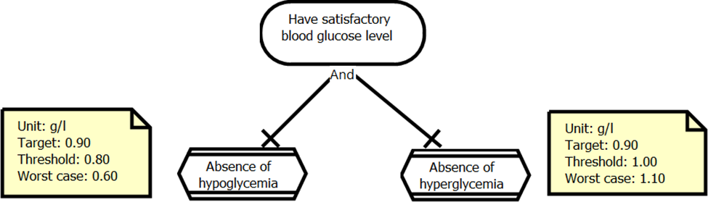

**Prompt 1E.13:** *Given the description of the Movie Awards and Rating System (MARS) and its GRL goal model, correct the mistake in the goal model. Assume that there are no missing elements in the goal model.*

*Domain Context: The Movie Awards and Rating System (MARS) is used by award organizations, productions companies, and members to advertise winners and nominees of movie awards, advertise TV series and movies, and rate episodes of TV series and movies, respectively. A user of the MARS must sign up for an account with a username and password to gain access to the system. Award organization and production companies must provide their name, while members must provide their nicknames. The MARS comes in two versions – the free regular version and the paid pro version. In the pro version, users have access to (i) award information not only from the current year but also from previous years as well as (ii) statistics. In some jurisdictions, regulations require the identity of users to be verified through a third-party verification service during the account sign-up phase. The yearly payment for the pro version is also provided by a third-party service, but no payment-related information is kept in the MARS for security reasons.*

*An award organization announces the winners of their yearly awards at a ceremony that is held in a different location each year. For example, the Academy of Motion Picture Arts and Sciences gives the Academy Awards (Oscars) every year in several different categories such as Best Picture, Best Director, and Best Actor. Some time before the award ceremony, several nominees are announced for each category. The categories are often the same each year, but small changes have been made in the Oscar’s history. The MARS allows award organizations to create a new award category if none of the existing categories match. The same categories may be used by other awards, e.g., the Golden Globes also announce a Best Picture, Best Director, and so on. Although not very common, one organization may administer several yearly awards.*

*A production company may advertise their TV series and movies in the MARS. Only a single production company is responsible for a movie. The episodes of a TV series are organized into seasons, and a single production company is responsible for a season, i.e., the production company for a TV series may change from one season to the next. Some production companies follow a September to April schedule for a season, while others follow a January to June schedule, while others follow a different yearly schedule altogether. For each produced show, a production company specifies the crew members (e.g., actors, directors, cinematographers, composers). For each crew member, the name of the artist, the date of birth, and a short bio are provided if this information does not yet exist in the MARS. Furthermore, the production company selects the position of the crew member for the produced show from a predefined list in the MARS.*

*Last but not least, a member may rate a movie or an episode of a TV series from zero to five stars.*

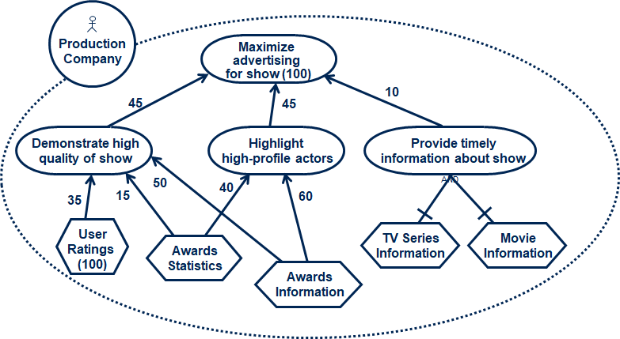

**Answer:** Importance is used for high-level goals and not for tasks such as “User Ratings”.

**Prompt 1E.14:** *Given the description of the Movie Awards and Rating System (MARS) and its GRL goal model, correct the mistake in the goal model. Assume that there are no missing elements in the goal model.*

*Domain Context: The Movie Awards and Rating System (MARS) is used by award organizations, productions companies, and members to advertise winners and nominees of movie awards, advertise TV series and movies, and rate episodes of TV series and movies, respectively. A user of the MARS must sign up for an account with a username and password to gain access to the system. Award organization and production companies must provide their name, while members must provide their nicknames. The MARS comes in two versions – the free regular version and the paid pro version. In the pro version, users have access to (i) award information not only from the current year but also from previous years as well as (ii) statistics. In some jurisdictions, regulations require the identity of users to be verified through a third-party verification service during the account sign-up phase. The yearly payment for the pro version is also provided by a third-party service, but no payment-related information is kept in the MARS for security reasons.*

*An award organization announces the winners of their yearly awards at a ceremony that is held in a different location each year. For example, the Academy of Motion Picture Arts and Sciences gives the Academy Awards (Oscars) every year in several different categories such as Best Picture, Best Director, and Best Actor. Some time before the award ceremony, several nominees are announced for each category. The categories are often the same each year, but small changes have been made in the Oscar’s history. The MARS allows award organizations to create a new award category if none of the existing categories match. The same categories may be used by other awards, e.g., the Golden Globes also announce a Best Picture, Best Director, and so on. Although not very common, one organization may administer several yearly awards.*

*A production company may advertise their TV series and movies in the MARS. Only a single production company is responsible for a movie. The episodes of a TV series are organized into seasons, and a single production company is responsible for a season, i.e., the production company for a TV series may change from one season to the next. Some production companies follow a September to April schedule for a season, while others follow a January to June schedule, while others follow a different yearly schedule altogether. For each produced show, a production company specifies the crew members (e.g., actors, directors, cinematographers, composers). For each crew member, the name of the artist, the date of birth, and a short bio are provided if this information does not yet exist in the MARS. Furthermore, the production company selects the position of the crew member for the produced show from a predefined list in the MARS.*

*Last but not least, a member may rate a movie or an episode of a TV series from zero to five stars.*

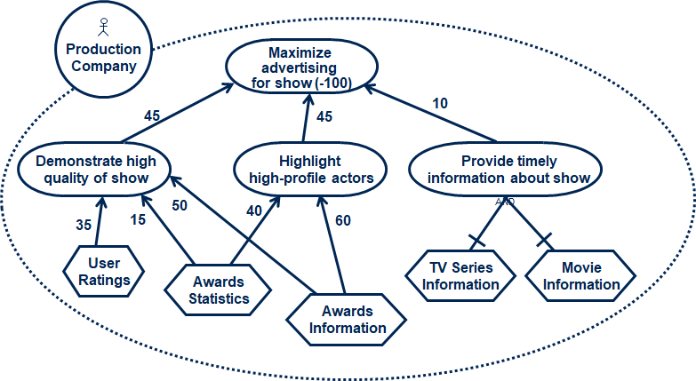

**Answer:** Importance cannot be negative.

**Prompt 1E.15:** *Given the description of the Movie Awards and Rating System (MARS) and its GRL goal model, correct the mistake in the goal model. Assume that there are no missing elements in the goal model.*

*Domain Context: The Movie Awards and Rating System (MARS) is used by award organizations, productions companies, and members to advertise winners and nominees of movie awards, advertise TV series and movies, and rate episodes of TV series and movies, respectively. A user of the MARS must sign up for an account with a username and password to gain access to the system. Award organization and production companies must provide their name, while members must provide their nicknames. The MARS comes in two versions – the free regular version and the paid pro version. In the pro version, users have access to (i) award information not only from the current year but also from previous years as well as (ii) statistics. In some jurisdictions, regulations require the identity of users to be verified through a third-party verification service during the account sign-up phase. The yearly payment for the pro version is also provided by a third-party service, but no payment-related information is kept in the MARS for security reasons.*

*An award organization announces the winners of their yearly awards at a ceremony that is held in a different location each year. For example, the Academy of Motion Picture Arts and Sciences gives the Academy Awards (Oscars) every year in several different categories such as Best Picture, Best Director, and Best Actor. Some time before the award ceremony, several nominees are announced for each category. The categories are often the same each year, but small changes have been made in the Oscar’s history. The MARS allows award organizations to create a new award category if none of the existing categories match. The same categories may be used by other awards, e.g., the Golden Globes also announce a Best Picture, Best Director, and so on. Although not very common, one organization may administer several yearly awards.*

*A production company may advertise their TV series and movies in the MARS. Only a single production company is responsible for a movie. The episodes of a TV series are organized into seasons, and a single production company is responsible for a season, i.e., the production company for a TV series may change from one season to the next. Some production companies follow a September to April schedule for a season, while others follow a January to June schedule, while others follow a different yearly schedule altogether. For each produced show, a production company specifies the crew members (e.g., actors, directors, cinematographers, composers). For each crew member, the name of the artist, the date of birth, and a short bio are provided if this information does not yet exist in the MARS. Furthermore, the production company selects the position of the crew member for the produced show from a predefined list in the MARS.*

*Last but not least, a member may rate a movie or an episode of a TV series from zero to five stars.*

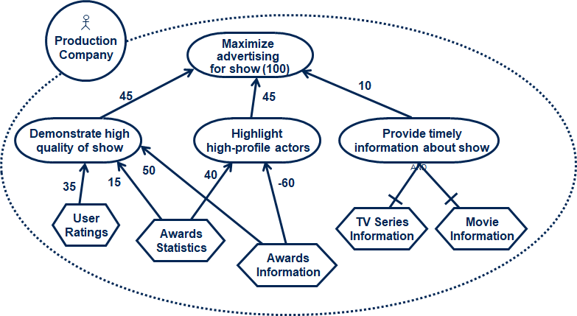

**Answer:** The “Awards Information” task does not contribute negatively but rather positively to the “Highlight high-profile actors” goal.

**Prompt 1E.16:** *Given the description of the Movie Awards and Rating System (MARS) and its GRL goal model, correct the mistake in the goal model. Assume that there are no missing elements in the goal model.*

*Domain Context: The Movie Awards and Rating System (MARS) is used by award organizations, productions companies, and members to advertise winners and nominees of movie awards, advertise TV series and movies, and rate episodes of TV series and movies, respectively. A user of the MARS must sign up for an account with a username and password to gain access to the system. Award organization and production companies must provide their name, while members must provide their nicknames. The MARS comes in two versions – the free regular version and the paid pro version. In the pro version, users have access to (i) award information not only from the current year but also from previous years as well as (ii) statistics. In some jurisdictions, regulations require the identity of users to be verified through a third-party verification service during the account sign-up phase. The yearly payment for the pro version is also provided by a third-party service, but no payment-related information is kept in the MARS for security reasons.*

*An award organization announces the winners of their yearly awards at a ceremony that is held in a different location each year. For example, the Academy of Motion Picture Arts and Sciences gives the Academy Awards (Oscars) every year in several different categories such as Best Picture, Best Director, and Best Actor. Some time before the award ceremony, several nominees are announced for each category. The categories are often the same each year, but small changes have been made in the Oscar’s history. The MARS allows award organizations to create a new award category if none of the existing categories match. The same categories may be used by other awards, e.g., the Golden Globes also announce a Best Picture, Best Director, and so on. Although not very common, one organization may administer several yearly awards.*

*A production company may advertise their TV series and movies in the MARS. Only a single production company is responsible for a movie. The episodes of a TV series are organized into seasons, and a single production company is responsible for a season, i.e., the production company for a TV series may change from one season to the next. Some production companies follow a September to April schedule for a season, while others follow a January to June schedule, while others follow a different yearly schedule altogether. For each produced show, a production company specifies the crew members (e.g., actors, directors, cinematographers, composers). For each crew member, the name of the artist, the date of birth, and a short bio are provided if this information does not yet exist in the MARS. Furthermore, the production company selects the position of the crew member for the produced show from a predefined list in the MARS.*

*Last but not least, a member may rate a movie or an episode of a TV series from zero to five stars.*

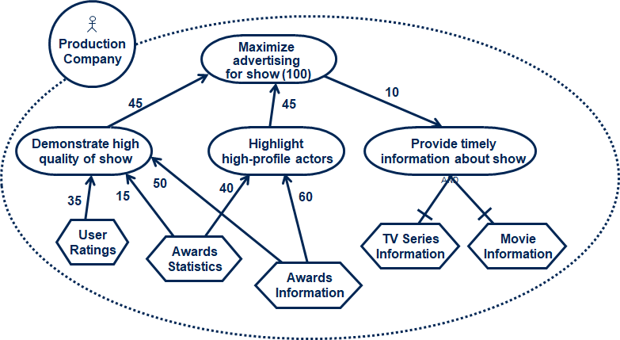

**Answer:** The contribution between “Maximize advertising for show” and “Provide timely information about show” goes in the wrong direction.

**Prompt 1E.17:** *Given the description of the Movie Awards and Rating System (MARS) and its GRL goal model, correct the mistake in the goal model. Assume that there are no missing elements in the goal model.*

*Domain Context: The Movie Awards and Rating System (MARS) is used by award organizations, productions companies, and members to advertise winners and nominees of movie awards, advertise TV series and movies, and rate episodes of TV series and movies, respectively. A user of the MARS must sign up for an account with a username and password to gain access to the system. Award organization and production companies must provide their name, while members must provide their nicknames. The MARS comes in two versions – the free regular version and the paid pro version. In the pro version, users have access to (i) award information not only from the current year but also from previous years as well as (ii) statistics. In some jurisdictions, regulations require the identity of users to be verified through a third-party verification service during the account sign-up phase. The yearly payment for the pro version is also provided by a third-party service, but no payment-related information is kept in the MARS for security reasons.*

*An award organization announces the winners of their yearly awards at a ceremony that is held in a different location each year. For example, the Academy of Motion Picture Arts and Sciences gives the Academy Awards (Oscars) every year in several different categories such as Best Picture, Best Director, and Best Actor. Some time before the award ceremony, several nominees are announced for each category. The categories are often the same each year, but small changes have been made in the Oscar’s history. The MARS allows award organizations to create a new award category if none of the existing categories match. The same categories may be used by other awards, e.g., the Golden Globes also announce a Best Picture, Best Director, and so on. Although not very common, one organization may administer several yearly awards.*

*A production company may advertise their TV series and movies in the MARS. Only a single production company is responsible for a movie. The episodes of a TV series are organized into seasons, and a single production company is responsible for a season, i.e., the production company for a TV series may change from one season to the next. Some production companies follow a September to April schedule for a season, while others follow a January to June schedule, while others follow a different yearly schedule altogether. For each produced show, a production company specifies the crew members (e.g., actors, directors, cinematographers, composers). For each crew member, the name of the artist, the date of birth, and a short bio are provided if this information does not yet exist in the MARS. Furthermore, the production company selects the position of the crew member for the produced show from a predefined list in the MARS.*

*Last but not least, a member may rate a movie or an episode of a TV series from zero to five stars.*

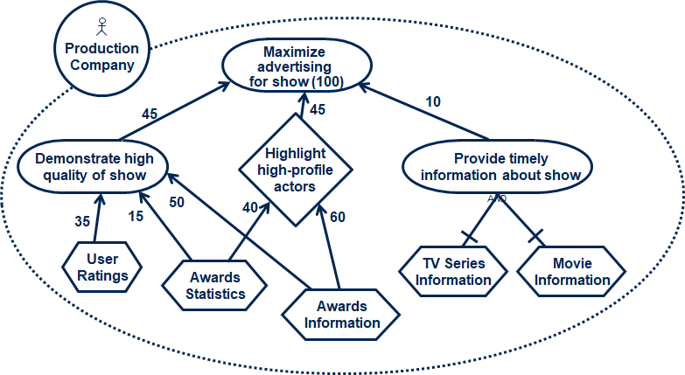

**Answer:** The diamond-shaped symbol for “Highlight high-profile actor” is not a valid GRL model element.